RESUME

Respected Sir,

I feel honored to introduce myself as writing this mail for the possibility of R.S in your research institute/university/organization. I am
B.V.CHAKRAVARTHI and I have completed M Phil, my dissertation entitled Studies on “Synthesis Characterization and Biological evaluation of novel Heterocyclic compounds(focus on Indole-Nitrogen heterocyclic derivatives)”.

I am writing to you to explore the possibility of working as a R&D with your esteemed research group, as such I am very much interested to carry out research work in the area of Organic Synthesis using different synthesized methods. I am very much interested to join in your group to carry out further research work. I would be grateful and glad if my curriculum vitae would be taken into your kind consideration and given an opportunity to work with you and your research group. I am here with enclosing my Curriculum Vitae for your kind perusal. I have published a good papers in reputed international journals and presented the essence of work in International/National conferences/seminars. I will be at your access, if any further information is needed. I assure you that, I will serve your research institute/university at my best if I am given an opportunity. I will furnish to the best of my abilities all the necessary details that you would like to have as regards any area of your interest.

Anticipating a positive correspondence from your desk. Kindly do the needful and hoping to hear from you soon. Looking forward for an opportunity to work with you and your group.

Thanking you,

Yours sincerely
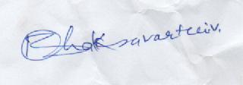

(B.V.CHAKRAVARTHI)

CURRICULUM VITAE


B.V.Chakravarthi
MSc ,M.Phil(PHD)
Lecturer in Chemistry
SVGM Govt Degree College
Kalyandurg

Email : bv.chakravarthi115@gmail.com
P NO : 7207423763

career Objective
To be associated with a progressive research group which can give challenging opportunities and ample scope to exhibit my skills with immense potential in changing the quality of life in years to come who are involved in exploring the hidden secrets of the nature and develop a concept which is novel to the scientific community that helps in solving various problems faced by mankind and better future.

Personal skills
A flexible novice ardent to learn innovative with good communicating skills, ability to handle fragile jobs with care and perfection, hardworking, ability to deal with people diplomatically, good team membership qualities.

Educational qualifications
UNDER RESEARCH FROM S.K UNIVERSITY
- M Phil. (PART - TIME)in chemistry (2008 - 2009): “Synthesis, Charectrarization and Biological Evaluation of Novel Heterocyclic Compounds(focus on Indole-Nitrogen heterocyclic derivatives)”. Research Guide: Prof.L.K Ravindranath Department of Chemistry, Sri Krishnadevaraya University, Anantapur, Andhra Pradesh, India.

- M.Sc. (Post-Graduation) in Chemistry (2001 - 2003) with “ Organic Chemistry” as specialization from Sri Krishnadevaraya University, Anantapuram, Andhra Pradesh, India,
- B.Sc. (Graduation) in MPC (1997-2000) with “Maths, Physics and Chemistry” as optional subjects from Sri Krishnadevaraya University, Anantapur, Andhra Pradesh, India.

- Intermediate (10+2 Standard) in MPC (1994-1996) with “Maths ,Physics and Chemistry” as optional subjects from Board of Intermediate Education, Hyderabad, Andhra Pradesh, India, with an aggregate of
- S.S.C. (10th standard) (1993) with “Mathematics, Physical Sciences and Social Studies” as group subjects from Board of Higher Education,

- Participated in National Seminars

- EMARGING TRENDSIN ELECTRO CHEMICAL STUDIES MARCH 25th -26th 2011 S.K.U.
- RECENT DEVLOPMENTS IN ELECTRO ANALYTICAL TECHNIQUES STUDIES 5th – 6th 2012 S.K.U.
- MODERN TRENDS IN CHEMICAL ANALYSIS DURING 28th -29th 2012 S.K.U.
- NATURAL PRODUCTS AND BIODIVERSITY OUR INSURANCE FOR THE FUTURE ON 12th DECEMBER 2014 KURNOOL.
- EMERGING TRENDS IN NANO CHEMISTRY DURING 20th &21st NOVEMBER 2015
- NANO MATERIALS AND GLOBAL PERSPECTIVES ON 30th & 31st JANUARY 2015 FROM GOVT DEGREE COLLEGE ANANTAPURAM.

- INTRODUCTION TO ENTREPRENEURSIP FROM 17th – 19th APRIL 2016 P.R.GOVT.COLLEGE. KAKINADA E.G.DIST
- A FOUNDATION COURSE IN HUMAN VALUES AND PROFESSIONAL ETHICS FROM 8th – 10th 2013 GOVERNMENT COLLEGE (MEN),ANANTAPURAM.

AREAs OF RESEARCH SPECIALIZATION
Organic synthesis (Heterocyclic compounds)

Title of the M Phil., dessartation
“Synthesis, Charectrarization and Biological Evaluation of Novel Heterocyclic compounds”
”(focus on Indole-Nitrogen heterocyclic derivatives) ”

Research INTEREST
- SYNTHETIC ORGANIC CHEMISTRY
- ISOLATION OF NATURAL PRODUCTS
- SPECTRAL ANALYSIS OF ORGANIC COMPOUNDS

Research/technical experience
Research activities are in the area of Synthetic Organic chemistry. The major area of research work carried out involves, synthesis of different types of Heterocyclic Compounds using different synthetic techniques and investigation of its chemical structures by IR, H¹NMR, ¹³CNMR, UV, Mass and other structural techniques.
As a M Phil. student, I also supported to conduct various experiments with above mentioned techniques. I have good exposure in handling the equipment and familiarity in analyzing and interpretation of results obtained by various scientific experiments.

summary of M Phil. research work
I have completed M Phil. in the Department of Chemistry, Sri Krishnadevaraya University, Anantapur, India. The thesis entitled “Synthesis, Charectrarization and Biological Evaluation of Novel Heterocyclic compounds”
“(focus on Indole-Nitrogen heterocyclic derivatives) ”
Heterocycles and medicines are both inter related because humans are totally dependent on the drugs derives from heterocyclic rings. Hetero cycles and their derivatives have attracted the attention of chemists. Mainly because of broad spectrum biological and pharmacological activities associated with this class of compounds specially having Nitrogen, Sulphur and Oxygen or three hetero atoms The indole ring is a prominent structural moiety found in numerous pharmaceutically active compounds. Indole and indole ring systems represent an important class of compounds not only for their theoretical interest but also for their Anti-inflammatory, postmenopausal, Osteoporosis, angiotension, antagonisis ,and anticoagulant activities. This is mainly due to the ease preparation and the important biological activity. Indole framework plays an essential role in biologically active compounds and therefore represents an interesting template for combinatorial as well as medicinal chemistry. Such as antibacterial, antifungal, antiviral, antitubercular⁹, antiamoebic, antiandrogenic, etc. Some of these compounds have also exhibited antidiabetic, herbicidal activity analgesic and antiparasitic properties. Many Indoles have been found to be luminescent and fluorescent agents. In addition Indoles have played a crucial role in the development of theory in heterocyclic chemistry and also used extensively as useful synthon in organic synthesis. This has prompted us to synthesize some of the pyrazolopyrazole derivatives by using hydrazine hydrate, Phenyl hydrazine Thiosemicarbazide and Semicorbozide. It has been considered worthwhile to incorporate a suitable functionality into these derivatives to potentate their pharmacological activity.
indole nucleus is frequently found in medicinal chemistry it has been considered as privileged scoffords, indole derivatives important class of therapeutic agents such as anticancer, anti HIV activity. the indole derivatives is used as a starting material for the synthesis of large number of alkaloids in addition to alkaloids some antibiotics derived from microbial sources are also known to possess indole nucleus. To isolate a compound, which can exhibit either like or antagonistic property with respect to alkaloids or antibiotics, a large number of their structural analogues have been synthesized and screened to know their biological properties. These compounds were screened for antiserotonin and antihistaminic activity. and same way pyridine ,pyrrole derivatives are also highly potent biologically active compounds.
Encouraged by these results, it was planned to synthesize new chemical entities incorporating the two active pharmacophores, Indole and Heteronucleous in a single molecular framework using chalcones of Indole and Heterocyclic aldehydes as basic building blocks. These Chalcones further react with other molecular entities to form resulting structures.

RESEARCH WORK:
(1)Synthesis of indole derivatives containing pyrazolone moiety bearing-4-oxazetidinone and biological Evaluation of pyrazolone
(2)Synthesis of indole derivaties containing 1,3,4 oxadiazole moiety bearing- Thiazolidinone and biological Evaluation of 1,3,4 oxadiazole
(3)Synthesis Characterization and biological evaluation of novel indole derivatives containing Thiazole moiety bearing-Tetrazole and biological Evaluation of Thiazole
(4) Synthesis of certain novel mannich bases containing indole
bearing phenyl thiazole and biological Evaluation of phenyl thiazole.
(5) Synthesis of ureides containing indole moiety bearing -4- oxazetidinone and biological Evaluation of ureides.
Best publications:
1)Synthesis of pyrazolone derivatives containing indole moiety
bearing-4-oxazetidinone
S. Muralikrishna, P. Raveendrareddy, L. K. Ravindranath, S. Harikrishna and B. V. Chakravarthi

2). SYNTHESIS CHARECTERIZATION AND BIOLOGICAL ACTIVITY OF SOME PYRIMIDINE DERIVATIVES
Dr. P. Jagadeeswra Rao*1, M. Veenu Gopal2, S. Maasma Shaheen3, B. V. Chakrathi3
3) Synthesis of some novel Mannich bases bearing pyrazolone moiety

L. K. Ravinrdanath, B. V. Chakravarthi, S. Muralikrishna and S. Harikrishna
4) SYNTHESIS AND SCREENING OF (E)-1-(4-(2-(((PHENYLAMINO)METHYL) AMINO)ACETYL)PHENYL)-4-(2-PHENYLHYDRAZONO)-3(TRICHLOROMETHYL) -1H-PYRAZOL-5(4H)-ONE

L.K.Ravinrdanath, *B.V.Chakravarthi S.Muralikrishna

Department of chemistry, S.K.University, Anantapuram
Email ID; BV.CHAKRAVARTHI 115@gmail.com

teaching EXPERIENCE AS A LECTURER
- GOVT DEGREE COLLEGE TADAPATHRI 2003 to 2006
- GOVT DEGREE COLLEGE MADAKASIRA 2011 to 2017
- GOVT DEGREE COLLEGE RAYADURG 2017 to Till To Date

computational skills
Languages : C/C⁺⁺ programming

Operating Platform : MS.Office

Graphics Packages : Origin, Excel, Chemdraw

research collaboration
- S K University of Anantapuram, India
- AndhraUniversity, Visaka pattanum- India

PERSONAL PROFILE
 | Date of birth : | 05 -01-1978
 | Gender : | Male
 | Marital Status : | Married
 | Nationality : | Indian-Hindu
 | Languages : | English, Hindi and Telugu
 | Permanent Address : | B.V CHAKRAVARTHI  S/o. B.Venkatrao  H.NO:3-645  Somanath Nagar Anantapuram  Andhra Pradesh, India.

declaration
I hereby solemnly affirm that all the details that are furnished in my curriculum vitae are true and best up to my knowledge, if found any falsity in this concerned information furnished then I will be liable for any disciplinary action taken by the concerned authority.

Signature
B.V.CHAKRAVARTHI

B.V.CHAKRAVATHI LECTURER IN CHEMISRY M se, M Phil MARKS CERTIFICATES

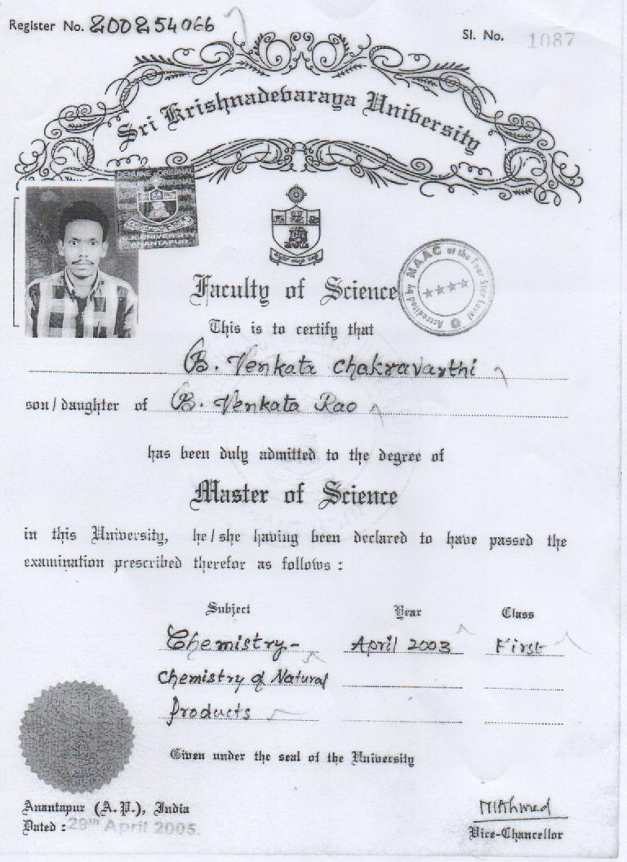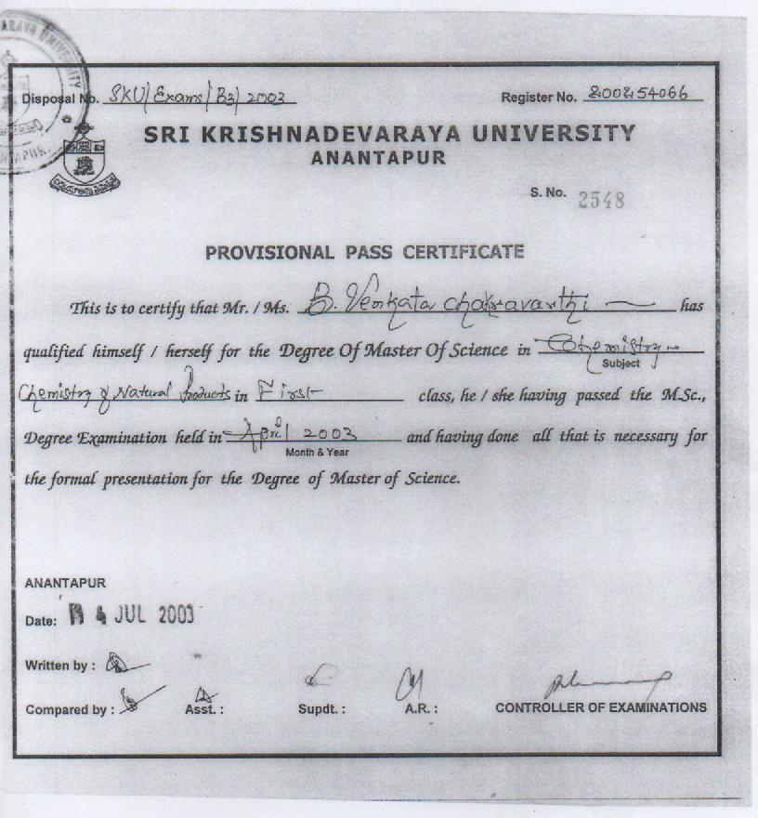s
NATIONAL SEMINERS CERTIFICATES FROM B.V.CHAKRAVARTHI DEPT CHEMISTRY K T S GDC RAYADURGAM

